Demographic Data
- year_1:Year of birth
  - Fill-in-the-blank question, where participants self-reported the year they were born. Responses ranged from 1922 to 2004. There was one blank answer.
  - Graphical frequency distribution of the responses:
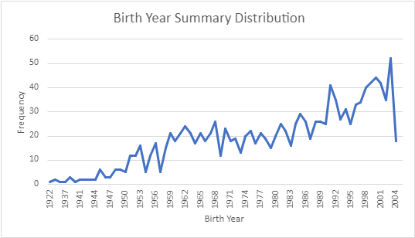
- gender_1: Gender
[1] - Male
n= 652
[2] - Female
n= 650
[3] - Other
n= 0
- ses_1: What is the socio-economic status of your home?
[1] - lower-low
n= 311
[2] - low
n= 349
[3] - upper-low
n= 385
[4] - medium
n= 137
[5] - medium-high
n= 101
[6] - high
n= 18
[Blank] - No answer provided
n= 5
- demographic_1: According to your culture, people, or physical features, you are or are recognized as:
[1] - Indigenous
n= 107
[2] - Gypsy
n= 4
[3] - Raizal from San Andres, Providencia and Santa Catalina Archipelago
n= 2
[4] - Palenquero from San Basilio
n= 0
[5] - Black, mulatto (Afro-descendant), Afro-Colombian
n= 346
[6] - None of the Above
n= 842
[Blank] - No answer provided
n= 5
- Parental Education
father_ed: How many years of education did your parents receive? Father
  - Fill-in-the-blank question, where participants self-reported their father’s education in years. Responses ranged from 0 to 20 years. There were 282 blank answers.
  - Graphical frequency distribution of the responses:
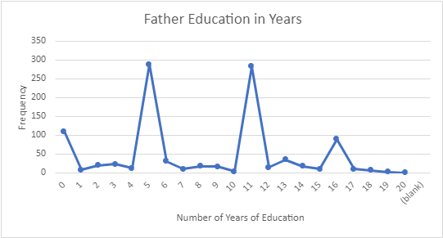
mother_ed: How many years of education did your parents receive? Mother
  - Fill-in-the-blank question, where participants self-reported their mother’s education in years. Responses ranged from 0 to 25 years. There were 203 blank answers.
  - Graphical frequency distribution of the responses:
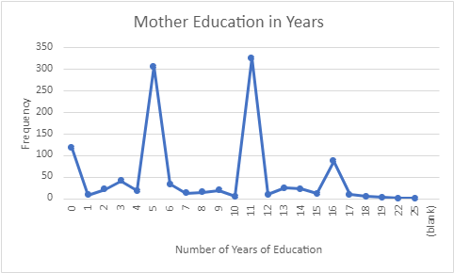

Subjective Well Being
swb_X: Subjective Well Being
- In general, how satisfied are you with all aspects of your life? With 0 being not satisfied, and 10 being totally satisfied.
Response | 0 | 1 | 2 | 3 | 4 | 5 | 6 | 7 | 8 | 9 | 10
# | 11 | 2 | 7 | 5 | 16 | 73 | 68 | 166 | 302 | 148 | 508

The following questions are about how you felt yesterday on a scale of 0 to 10. Zero means that you didn't experience these feelings “at no time” while 10 means that you experienced these feelings “all the time”.
- How happy did you feel yesterday?
Response | 0 | 1 | 2 | 3 | 4 | 5 | 6 | 7 | 8 | 9 | 10 | Blank
# | 28 | 5 | 26 | 21 | 29 | 107 | 53 | 108 | 194 | 161 | 573 | 1

- How much did you laugh yesterday?
Response | 0 | 1 | 2 | 3 | 4 | 5 | 6 | 7 | 8 | 9 | 10 | Blank
# | 69 | 19 | 39 | 43 | 41 | 148 | 63 | 104 | 182 | 111 | 481 | 6

- Did you learn new or exciting things yesterday?
Response | 0 | 1 | 2 | 3 | 4 | 5 | 6 | 7 | 8 | 9 | 10 | Blank
# | 107 | 15 | 42 | 33 | 36 | 218 | 101 | 138 | 198 | 109 | 304 | 5

- How much did you enjoy the activities you did yesterday?
Response | 0 | 1 | 2 | 3 | 4 | 5 | 6 | 7 | 8 | 9 | 10 | Blank
# | 42 | 11 | 15 | 27 | 35 | 102 | 56 | 108 | 198 | 149 | 560 | 3

- How worried did you feel yesterday?
Response | 0 | 1 | 2 | 3 | 4 | 5 | 6 | 7 | 8 | 9 | 10 | Blank
# | 435 | 44 | 96 | 85 | 56 | 140 | 69 | 81 | 96 | 56 | 146 | 2

- How depressed did you feel yesterday?
Response | 0 | 1 | 2 | 3 | 4 | 5 | 6 | 7 | 8 | 9 | 10 | Blank
# | 721 | 55 | 89 | 74 | 37 | 94 | 42 | 40 | 53 | 31 | 67 | 3

- How angry did you feel yesterday?
Response | 0 | 1 | 2 | 3 | 4 | 5 | 6 | 7 | 8 | 9 | 10 | Blank
# | 762 | 68 | 88 | 69 | 45 | 75 | 29 | 29 | 37 | 31 | 72 | 1

- How much stress did you feel yesterday?
Response | 0 | 1 | 2 | 3 | 4 | 5 | 6 | 7 | 8 | 9 | 10 | Blank
# | 573 | 48 | 87 | 81 | 52 | 114 | 57 | 58 | 71 | 44 | 117 | 4

- How lonely or unsupported did you feel yesterday?
Response | 0 | 1 | 2 | 3 | 4 | 5 | 6 | 7 | 8 | 9 | 10 | Blank
# | 782 | 53 | 67 | 52 | 34 | 85 | 33 | 43 | 61 | 20 | 73 | 3

Health
PSS-10_X: Next, you will be asked questions about your emotional state. Please answer on a scale of 0 to 4, where 0 is never, 1 is 'almost never', 2 is 'sometimes', 3 is 'fairly often,' and 4 is 'very often', How often you experienced the following feelings during the last month
- In the last month, how often have you been upset because of something that happened unexpectedly?
Response | 0 | 1 | 2 | 3 | 4 | Blank
# | 457 | 293 | 298 | 152 | 105 | 1

- In the last month, how often have you felt that you were unable to control the important things in your life?
Response | 0 | 1 | 2 | 3 | 4
# | 524 | 251 | 314 | 134 | 83

- How often have you felt nervous and stressed?
Response | 0 | 1 | 2 | 3 | 4 | Blank
# | 382 | 182 | 339 | 198 | 202 | 3

- (Reverse-coded)How often have you felt confident about your ability to handle your personal problems?
Response | 0 | 1 | 2 | 3 | 4 | Blank
# | 529 | 372 | 262 | 78 | 59 | 6

- (Reverse-coded)How often have you felt that things were going your way?
Response | 0 | 1 | 2 | 3 | 4 | Blank
# | 499 | 448 | 263 | 61 | 27 | 8

- How often you experienced the following feelings during the last month: how often have you found that you could not cope with all the things that you had to do?
Response | 0 | 1 | 2 | 3 | 4 | Blank
# | 388 | 329 | 340 | 172 | 71 | 6

- (Reverse-coded)How often have you been able to control irritations in your life?
Response | 0 | 1 | 2 | 3 | 4 | Blank
# | 409 | 426 | 320 | 83 | 59 | 9

- (Reverse-coded)How often have you felt that you were on top of things?
Response | 0 | 1 | 2 | 3 | 4 | Blank
# | 334 | 409 | 363 | 123 | 75 | 2

- How often have you been angered because of things that happened that were outside of your control?
Response | 0 | 1 | 2 | 3 | 4 | Blank
# | 351 | 260 | 332 | 226 | 136 | 1

- How often have you felt difficulties were piling up so high that you could not overcome them?
Response | 0 | 1 | 2 | 3 | 4 | Blank
# | 507 | 250 | 316 | 153 | 78 | 2
PSS-10_Score/Severity: Based on previous PSS-10_X responses, individuals’ cumulative scores for perceived stress were calculated and then categorized for level of severity:
- 0–13: low stress
  - n= 673
- 14–26: moderate stress
  - n= 592
- 27–40: high perceived stress
  - n= 41
- Range: 0-38
- Modal Response: 12
~~~~~~~~~~~~~~~~~~~~~~~~~~~~~~~~
GAD-7_X: Next, you will be asked questions about your emotional state. Please answer on a scale of 0 to 3, where 0 is 'Not at all', 1 is 'several days', 2 is 'more than half of the days', and 3 is 'Nearly every day'. Over the last two weeks, how often have you been bothered by the following problems?
- Feeling nervous, anxious, or on edge
Response | 0 | 1 | 2 | 3 | 4 | 5 | 6 | 7 | 8 | 9 | 10 | Blank
# | 664 | 307 | 183 | 151 | 0 | 0 | 0 | 0 | 0 | 0 | 0 | 1

- Not being able to stop or control worrying
Response | 0 | 1 | 2 | 3 | 4 | 5 | 6 | 7 | 8 | 9 | 10 | Blank
# | 806 | 249 | 149 | 110 | 0 | 0 | 0 | 0 | 0 | 0 | 0 | 1

- Worrying too much about different things
Response | 0 | 1 | 2 | 3 | 4 | 5 | 6 | 7 | 8 | 9 | 10 | Blank
# | 687 | 299 | 178 | 140 | 0 | 0 | 0 | 0 | 0 | 0 | 0 | 2

- Trouble relaxing
Response | 0 | 1 | 2 | 3 | 4 | 5 | 6 | 7 | 8 | 9 | 10 | Blank
# | 799 | 229 | 152 | 120 | 0 | 0 | 0 | 0 | 0 | 0 | 0 | 6

- Being so restless that it is hard to sit still
Response | 0 | 1 | 2 | 3 | 4 | 5 | 6 | 7 | 8 | 9 | 10 | Blank
# | 706 | 258 | 176 | 161 | 0 | 0 | 0 | 0 | 0 | 0 | 0 | 5

- Becoming easily annoyed or irritable
Response | 0 | 1 | 2 | 3 | 4 | 5 | 6 | 7 | 8 | 9 | 10 | Blank
# | 711 | 285 | 158 | 150 | 0 | 0 | 0 | 0 | 0 | 0 | 0 | 2

- Feeling afraid, as if something awful might happen
Response | 0 | 1 | 2 | 3 | 4 | 5 | 6 | 7 | 8 | 9 | 10 | Blank
# | 766 | 226 | 157 | 155 | 0 | 0 | 0 | 0 | 0 | 0 | 0 | 2

GAD-7_Score/Severity: Based on previous gad7_X responses, individuals’ cumulative scores for anxiety severity were calculated and then categorized for level of severity:
- 0–4: minimal anxiety
  - n= 739
- 5–9: mild anxiety
  - n= 279
- 10–14: moderate anxiety
  - n= 156
- 15–21: severe anxiety
  - n= 132
- Range: 0-21
- Modal Response: 0
~~~~~~~~~~~~~~~~~~~~~~~~~~~~~~~~
PHQ-9_X: Next, you will be asked questions about your emotional state. Please answer on a scale of 0 to 3, where 0 is 'Not at all', 1 is 'several days', 2 is 'more than half of the days', and 3 is 'Nearly every day'. Over the last two weeks, how often have you been bothered by the following problems?:
- Little interest or pleasure in doing things
Response | 0 | 1 | 2 | 3 | Blank
# | 805 | 268 | 144 | 88 | 1

- Feeling down, depressed, or hopeless
Response | 0 | 1 | 2 | 3 | Blank
# | 810 | 248 | 151 | 97 | 0

- Trouble falling or staying asleep, or sleeping too much
Response | 0 | 1 | 2 | 3 | Blank
# | 700 | 218 | 182 | 202 | 4

- Feeling tired or having little energy
Response | 0 | 1 | 2 | 3 | Blank
# | 540 | 341 | 244 | 177 | 4

- Poor appetite or overeating
Response | 0 | 1 | 2 | 3 | Blank
# | 783 | 196 | 182 | 141 | 4

- Feeling bad about yourself or that you are a failure or have let yourself or your family down
Response | 0 | 1 | 2 | 3 | Blank
# | 888 | 203 | 116 | 95 | 4

- Trouble concentrating on things, such as reading the newspaper or watching television
Response | 0 | 1 | 2 | 3 | Blank
# | 825 | 215 | 162 | 100 | 4

- Moving or speaking so slowly that other people could have noticed. Or the opposite being so figety or restless that you have been moving around a lot more than usual
Response | 0 | 1 | 2 | 3 | Blank
# | 952 | 176 | 104 | 72 | 2

- Thoughts that you would be better off dead, or of hurting yourself
Response | 0 | 1 | 2 | 3 | Blank
# | 1109 | 94 | 51 | 45 | 7

phq9_Score/phq9_severity: Based on previous phq9_XNUM responses, individuals’ cumulative scores for depression severity were calculated then categorized.
- 0: None
  - 263
- 1-4: Minimal depression
  - n= 456
- 5-9: Mild depression
  - n= 291
- 10-14: Moderate depression
  - n= 154
- 15-19: Moderately severe depression
  - n= 83
- 20-27: Severe depression
  - n= 59
- Range : 0-27
- Modal Response: 0

